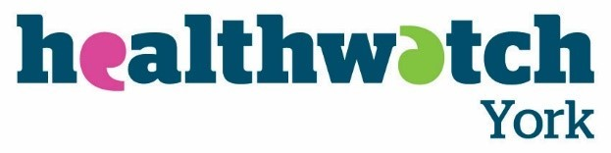
Community Pharmacy North Yorkshire - Healthwatch Survey
Thank you for taking part in this survey. Healthwatch York and Healthwatch North Yorkshire are working alongside Community Pharmacy North Yorkshire. We want to understand your views on community pharmacy. Your responses will help our local community pharmacies to understand what we do well and what we may need to improve
The survey is anonymous. It takes about 5-10 minutes to fill it in. The survey is open until Friday 16 June.
Thank you in advance for your time and help. We really appreciate it.

Please return this survey to:
Freepost RTEG-BLES-RRYJ
Healthwatch York
15 Priory Street
York YO1 6ET

1. How often do you visit your local community pharmacy?
Daily Quarterly
Weekly Once or twice per year
Monthly Never

2. Which pharmacy do you usually use?

3. Reasons for visiting the pharmacy (tick all that apply):
Collect prescription/s Purchasing medicines/other goods
Medicines Advice Blood pressure check
Healthcare Advice Other (please specify)
4. How would you rate the level of service you currently receive from your local pharmacy?
Excellent Satisfactory
Very Good Poor
Good
Any additional comments:
5. Are there any additional services you would like to see your local pharmacy offer?
6. What is usually your first port of call for healthcare advice?
GP Internet
Pharmacy A&E
NHS 111 (telephone or online) Friends
Other (please specify)
7. Have you had a FREE NHS flu vaccination this season (between September 2022 and March 2023)?
Yes No
8. Where did you receive your flu vaccination?
GP Vaccination centre
Pharmacy Hospital
Other (please specify)
9. Please tell us why you didn't have a free NHS flu vaccination
Not eligible
Preferred not to
Not eligible but paid for a private flu vaccination
No convenient time/location to access a vaccination
Other (please specify)

About you
The next few questions ask about you.
You do not need to answer any of these. But it helps us if you do.
10. Please tell us which area of York and North Yorkshire you live in
York Harrogate and District
Richmondshire Scarborough
Ryedale Selby
Craven Hambleton

11. Please tell us your age
17 or younger 45-54
18-24 55-64
25-34 65-74
35-44 75 or older

12. How would you describe your gender?

13. How good is your health in general?
Very Good Bad
Good Very Bad
Fair

14. Do you consider yourself to be:
A disabled person
A carer
A person with experience of mental ill-health
A person with a long term health condition
None of the above
Other (please specify)

15. If you would like an electronic copy of the final report, please provide your email address here:

Thank you for completing our survey.
Got more to say? Call us on 01904 621133 or email us at healthwatch@yorkcvs.org.uk

