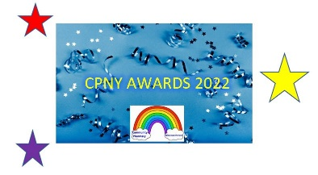
CPNY Awards 2022 Entry Form
Full name of nominee (if individual):
Pharmacy represented:
ODS Code:

Name of person submitting the nomination:
Contact Email address:

Which award category are you submitting a nomination for?

Pharmacy Team of the Year ☐ Unsung Hero/Outstanding Person ☐ Pharmacist of the Year ☐ HLP Champion of the Year ☐ Trainee Pharmacist of the Year ☐ Technology Award ☐
Local Healthcare Initiative of the Year ☐ Community Pharmacy Heroes of the Year ☐

What has the individual or pharmacy done to deserve this award?

Who benefited from this individual’s or pharmacy’s actions?

What difference did it make? What makes this individual or team stand out above the rest?

Each of the three sections above will be scored 1-5 during the judging process (5 being the best)
(Each answer limited to 100 words please)

Please email this form to: laura.smart@cpny.co.uk
The deadline for entries is Friday 20th May 2022

